
Department of BES-1
DATA STRUCTURES USIGN PYTHON
I-B.Tech-(II Sem), Academic Year: 2024-2025

Session 01 Algorithm Analysis:

Aim of the Session
To familiarize students with the basics of data structures, and algorithmic analysis to evaluate time complexities.

Objectives
This Session is designed to:
- Understand the concept of Data Structures.
- Learn the Mathematical background and Model.
- Analyze the algorithm to run time complexity.

Learning Outcomes

At the end of this session, you should be able to:

Evaluate the time complexities of the different Algorithmic solutions for various types of Problems.

Write the notations for calculating the running time complexity of different algorithms

Session Introduction
In this session we will discuss about
  - Basic definition of the Algorithm and Data structure
  - Definition of complexity of an Algorithm
  - Example of Time Complexity
  - Various Notations to find the performance of the algorithm

- Session Description
ALGORITHM:
A set of finite rules or instructions to be followed in calculations or other problem-solving operations (or)
A procedure for solving a mathematical problem in a finite number of steps that frequently involves recursive operations
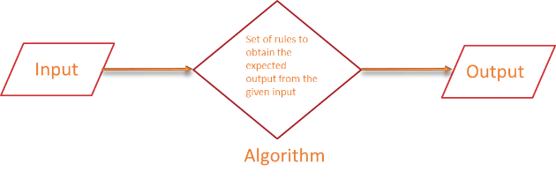
Fig 1: Basic flow of an algorithm
DATA STRUCTURE:
- Data Structures are used to store and organize the data in memory in an efficient manner
- It is a way of arranging data on a computer so that it can be accessed and updated efficiently.
- Data Structure is not only used for organizing the data but also used for processing, retrieving, and storing data.
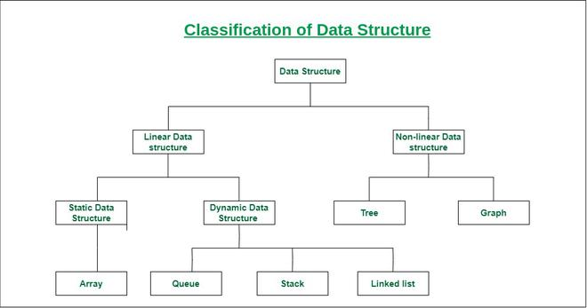
PERFORMANCE ANALYSIS OF AN ALGORITHM
The performance of an algorithm depends on the following elements...
- Whether that algorithm is providing the exact solution for the problem?
- Whether it is easy to understand?
- Whether it is easy to implement?
- How much space (memory) it requires to solve the problem?
- How much time it takes to solve the problem? Etc.,
“Performance analysis of an algorithm is the process of calculating space and time required by that algorithm”
COMPLEXITY OF AN ALGORITHM:
- Complexity in algorithms refers to the amount of resources (such as time or memory/Space) required to solve a problem or perform a task.
- The most common measure of complexity is time complexity, which refers to the amount of time an algorithm takes to produce a result as a function of the size of the input.
- Memory/Space complexity refers to the amount of memory used by an algorithm.
TIME COMPLEXITY:
- Time taken by the algorithm to solve the problem.
- It is measured by calculating the iteration of loops, the number of comparisons etc.
- Time complexity is a function describing the amount of time an algorithm takes in terms of the amount of input to the algorithm.
Example:
Consider the following Algorithm:
Step 1: Start takes 0 time to run
Step 2: Declare and initialize sum and i takes 1 time to run
Step 3: Read n value takes 1 time to run
Step 4: Repeat Step 5 until i = n takes n time to run
Step 5: sum+=i; takes 1 time to run
Step 6: print sum takes 1 time to run
Step 7: Stop takes 0 time to run
Ans: Total time complexity = 0+1+1+(n*1)+1+1+0
= n+4
= n (remove constant terms)
Time complexity for the above algorithm is O(n)
def get_first(data):
return data[0]
if __name__ == '__main__':
data = [1, 2, 9, 8, 3, 4, 7, 6, 5]
print(get_first(data))
Ans: O(1)
SPACE COMPLEXITY:
Suppose consider the following code:
Suppose consider the following code:
def sum(x, y, z):
total = x + y + z;
return total;
In the above expression, variables total, x, y and z are all integer types, hence they will take up 4 bytes each, so the total memory requirement will be (4(4) + 4) = 20 bytes, this additional 4 bytes is for return value.
In the above expression, variables total, x, y and z are all integer types, hence they will take up 4 bytes each, so the total memory requirement will be (4(4) + 4) = 20 bytes, this additional 4 bytes is for return value.
Self-Assessment Questions (SAQs)
Q1:
Identify the two types of efficiencies that are important for computer algorithms?
a) Time efficiency and Higher power efficiency
b) Higher power efficiency and Computational efficiency
c) Computational efficiency and Space efficiency
d) Space efficiency and Time Efficiency
Ans: d
Q2:
2. What is the time complexity of accessing an element in an array by index?
A) O(n)
B) O(log⁡n)
C) O(1)
D) O(n2)
Ans: C
Summary

Understand the concept of Data Structures.

Learn the Mathematical background and Model.

Analyse the algorithm to run time complexity.

Introduction about the Algorithm and Data Structure

Calculation of the Time and Space complexity of an algorithm to find out its efficiency

Terminal Questions
- What is a data structure, and why is it important in computer science?
- Differentiate between linear and non-linear data structures with examples.
- How is time complexity measured?
- Which of the following best describes the useful criterion for comparing the efficiency of algorithms?

REFERENCES FOR FURTHER LEARNING OF THE SESSION:

Reference Books:
- Data Structures and Algorithm Analysis in PYTHON, 2010, Mark Allen Weiss, Second Edition, Pearson Education.
- Data Structures and Algorithms, A.V.Aho, J.E.Hopcroft, and J.D.Ullman, Pearson Education, First Edition Reprint2003.
- Advanced Guide to Python 3 Programming, John Hunt, 4th Edition, Springer Nature Switzerland AG 2019.
- Python Basics: A Practice Introduction to Python 3, David Amos, Dan Bader, Joanna Jablonski, Fletcher Heisler, 4th edition, Real Python.

Sites and Web links:
  - https://docs.python.org/3/tutorial/datastructures.html
  - https://www.w3schools.com/dsa/dsa_intro.php
  - https://www.geeksforgeeks.org/python-data-structures/
  - https://onlinecourses.nptel.ac.in/noc25_cs59/preview
  - https://www.coursera.org/learn/python-data
  - https://www.codecademy.com/learn/learn-data-structures-and-algorithms-with-python

